Name of Student : Raghav Mahesh Sarda PRN: 25070122235
Subject: Programming with Java Semester: III
ASSIGNMENT No : 12 Year: AY 2026-27
TITLE : User-Defined Packages

Problem Statement
Write a Java program to create and use user-defined packages.

Learning Objectives
To create and use user-defined packages for organizing Java programs.

Program:
StudentDetails.java
// File 1: student/StudentDetails.java
package student; // Package declaration
public class StudentDetails // Class must be public to be accessed outside package
{
public void showDetails(String name, int roll) // Public method
{
System.out.println("Student: " + name + " | Roll: " + roll);
}
}

FacultyDetails.java
// File 2: faculty/FacultyDetails.java
package faculty; // Package declaration
public class FacultyDetails // Public class
{
public void showDetails(String name, String dept) // Public method
{
System.out.println("Faculty: " + name + " | Department: " + dept);
}
}

CollegeManagementSystem.java
// File 3: CollegeManagementSystem.java (Main Program)
import student.StudentDetails; // Importing user-defined package class
import faculty.FacultyDetails; // Importing user-defined package class
import java.util.*;

public class CollegeManagementSystem
{
public static void main(String args[]) // Main method
{
Scanner sc = new Scanner(System.in);
System.out.print("Enter Student Name and Roll No: ");
String sn = sc.next();
int sr = sc.nextInt();
System.out.print("Enter Faculty Name and Department: ");
String fn = sc.next();
String fd = sc.next();

StudentDetails sObj = new StudentDetails(); // Creating instance from student package
FacultyDetails fObj = new FacultyDetails(); // Creating instance from faculty package

System.out.println("\n-- College Management System --");
sObj.showDetails(sn, sr); // Calling package method
fObj.showDetails(fn, fd); // Calling package method
sc.close();
}
}
__________________________________________________
CollegeManagementSystem.java
// File 1: library/Book.java
package library; // Package declaration
public class Book // Public class
{
public void displayBook(int id, String title, String author, double price) // Public method
{
System.out.println("Book ID: " + id);
System.out.println("Title: " + title);
System.out.println("Author: " + author);
System.out.println("Price: $" + price);
}
}

Library.java
// File 2: Library.java (Main Program)
import library.Book; // Importing user-defined package class
import java.util.*;
public class Library
{
public static void main(String args[]) // Main method
{
Scanner sc = new Scanner(System.in);
System.out.print("Enter Book ID: ");
int bid = sc.nextInt();
sc.nextLine(); // Consuming newline
System.out.print("Enter Book Title: ");
String bt = sc.nextLine();
System.out.print("Enter Book Author: ");
String ba = sc.nextLine();
System.out.print("Enter Book Price: ");
double bp = sc.nextDouble();

Book bObject = new Book(); // Creating instance from library package

System.out.println("\n-- Library Record --");
bObject.displayBook(bid, bt, ba, bp); // Calling package method
sc.close();
}
}

Output:
CollegeManagementSystem.java
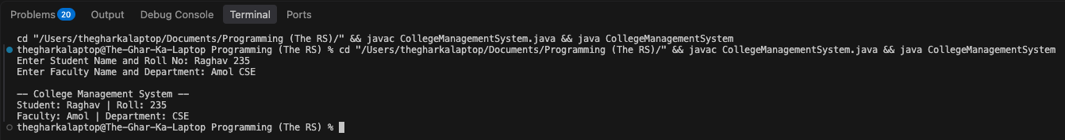

Library.java
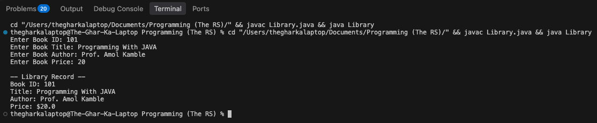

Conclusion:
In this assignment, the concepts of code organization, namespace management, and access protection using user-defined packages were successfully implemented. By grouping related classes into separate directory structures like student, faculty, and library, the programs achieved modular application development, prevented naming conflicts, and established an organizational structure for larger Java projects.

